Activity Application:
Local activities supporting the Campaign “Students and Youth in Action for World Refugee Day 2021”.

With only 3% of the refugee population having access to Higher Education in the world, what can students and youth do to support the objective of the UNHCR to reach 15% by 2030?
Let’s not forget that it’s not only about access, but also how can newcomers students enjoy university life, meet new people, participate actively in the student’s life in order to grow personally, build skills and knowledge and succeed!

Send us by email your Project Application (compulsory)
* by 16th of May 23:59 pm CET to movingforward@esu-online.org
* mention “Application Form_Country_Name of your activity” as a subject.

We will send the notification email around the 24th of May.

CONTACT DETAILS: Tell us who you are!
Who’s behind the project  (delete the other option) | - (A) a registered not-for-profit organisation / NGO  - (B) an informal group of students/youth

A- If you are a not-for-profit organisation/NGO
Organisation’s name
Brief description of the organisation with clear links to involvement of students and youth
Type of organisation
Country, City
Name of the contact person
Role in organisation
Telephone number
Email
Website of the organisation

B- If you are an informal group of students/youth
Tell us more about your group (who you are, what are you studying, your motivation)
Country, city
Name of the contact person
Role in the project
Telephone number
Email

Did you already apply to similar funding opportunities (local, national or European grant)? | - YES  - NO
Did you already apply to the Together, Moving Forward small grants Programme?* | - YES  - NO

Activity title

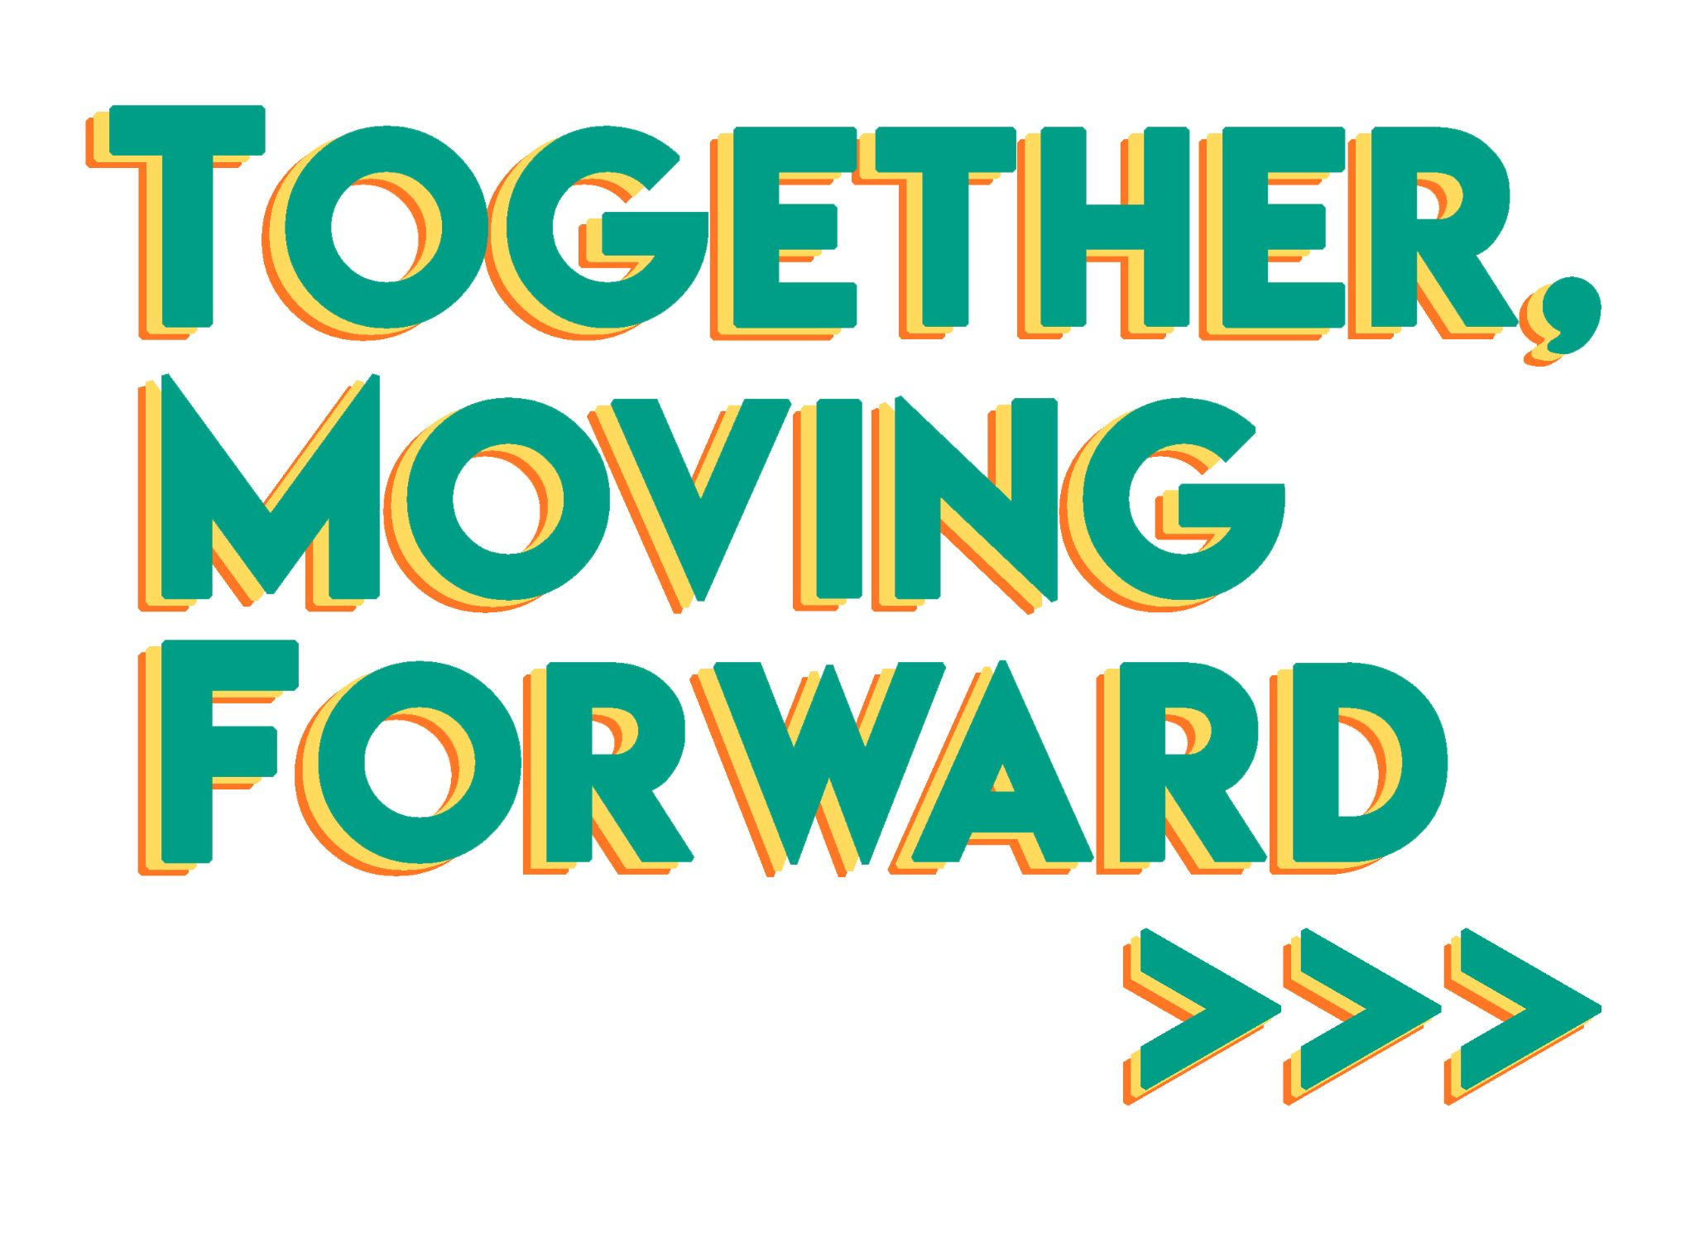
- What will be the main focus of your activities?
You can delete the topics not covered by your activity. Your activity can include several options.

- Access to education and higher education
- Social and cultural life of students and youth
- Wellbeing: mental health and physical activity of students and prospective students
- Developing new skills and knowledge for students and youth
- Awareness raising on migration challenges, educational barriers, youth participation
- Tackling consequences of the Covid-19 Pandemic for students and youth
- Other (please specify): …………………………..

2. Objectives and Activities - Give us a brief description of your activity
- Tell us more about the aim of your project. What do you plan to achieve in order to support the objective of the Call and the Campaign? Does your project propose solutions to overcome challenges raised in the Covid-19 pandemic?
- Tell us how concretely you will reach this objective? For example: what type of activity do you plan to implement? Who will be in charge? Do you plan to work with other organisations?
- How many people do you plan to reach and involve?
- Inclusion - What will be the role of young people with migrant and refugee backgrounds in your project?
- When your activity will be delivered?

3. It’s all about motivation… and planning!
Give us some examples of tasks you will have to do with your team to set up the activity in order to reach your objectives! You can also tell us when do you plan to conduct each of them (approximately)
- example of task
- example of task
- example of task
- example of task
- example of task

4. Budget - you will receive between 300 and 500 euros. How will you spend the money?
[Explain how you will use the money. Example: pay a trainer for a workshop, rent a room for a workshop, buy some snacks for closing an activity, print some posters, etc...]

5. Anything else you would like to share with us?

In both cases, we do not ask the question as a way to select projects, but rather to know if we need to propose specific support and attention during the application process - and project implementation, if successfully selected.

